**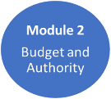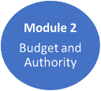****Part 1 – Rapid Assessment Tool**

**1. Deal Desk Economics**

|  |  |
| --- | --- |
| **Company Name:** |  |
| **Review Date:** |  |
| **Sales Rep / SE / Partner Rep:** |  |
| Initial Deal Size Range: i.e. $150 – 200k |  |
| Number of years of support being sold? |  |
| Expected Discount Level %: |  |
| Expected Gross Margin %: |  |
| Forecasted Close Date: |  |
| Opportunity Number (in SFDC): |  |
| Is Deal Desk approval required?  Yes / NO |  |

1. What are we SELLING (Product and License Type; Perpetual, Subscription, Cloud)?
2. What Additional Revenue can we expect in the next 12 – 24 months?
3. If there is additional revenue, what is the Get-Well Plan to reduce future discounts / Improve Margins?
4. Are there any Special Terms and Conditions we might not like? What are they?

**2. Budget and Authority**

1. Has the Budget been approved - Yes / No?
2. Has the Budget been released – Yes / No?
3. Has anything changed in the customer’s Approval process? Explain.

**Complete and Review Relationship Map Template**

1. Are you speaking with the Decision Maker who has Final Authority to spend the budget?
2. Have you or your boss met them in Person?

**3. Needs and Timing**

1. What Needs and Business Outcomes will the solution address?
2. Is the solution Strategically Relevant, Tactically Urgent and provide Rapid Time to Value? Explain.
3. What is the Compelling Event that will ensure the deal closes as forecasted?
4. What happens if you miss the Compelling Event?

**Part 2 - Big Rock Review – Deep Dive**

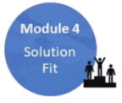

**4. Solution Fit**

1. What are the customer's Selection Criteria? / Are we a good Fit?
2. How has the customer discovered our Value; Presentation, Demo, POC, other?
3. What part of our value proposition has grabbed the most customer attention?
4. Has your Sales Leader met the Customer?
5. What Business outcomes is the customer expecting to achieve from the solution?

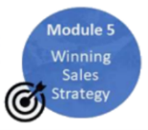

**5. Winning Sales Strategy**

1. What is your STRATEGY to WIN other than low price?

* Upgrade, Tech Refresh, Rip and Replace, Land and Expand, New Workload Expansion

1. Who is the Incumbent Technology provider?
2. Who is the Primary Competitor and what is their strategy to Beat you?
3. What part of the customer’s Cloud Strategy is competitive with the solution you are   
    recommending?

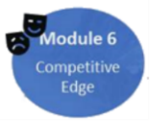

**6. Competitive Edge**

1. How are you Perceived in the account?

* Product Vendor, Credible Source, Problem Solver, Trusted Advisor?

1. Do you have Access to Power? Explain How.
2. Have you met the Key Decision Maker(s) in Person?
3. Who is your Coach and are they sharing key inside information about how your   
    campaign is being perceived inside the account?

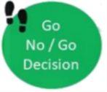

**Go / No Go Decision Point**

1. Based on what you know now, why should you continue Pursuing the opportunity?

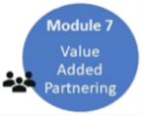

**7. Value Added Partnering**

1. Who is the Registered channel Partner, and have you shown up Together with   
    them at the Customer?
2. Do you have a Roles and Responsibilities Agreement (email) with the partner?
3. How is the partner Adding Value in the sales campaign?
4. Is there an Alliance Partner involved: Cisco, MS, VMware, NetApp, HPE, Nimble,   
    Pure and how are they Adding Value?

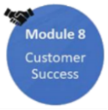

**8. Customer Success**

1. What is your strategy to ensure Customer Success after you win the deal?
2. What Risks could cause the project to Fail?
3. What Support Level have you quoted?
4. What Services are required and who will deliver them?

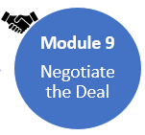

**9. Negotiate the Deal**

1. What is the Customer’s approach to negotiating with Vendors?
2. How many rounds of negotiating with the Customer do you expect?
3. Will the deal be negotiated with the End User or the Procurement Department?

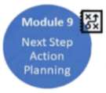

**10. Next Step Action Planning**

1. **Critical Look Back Question:** If the prospect were to notify you today that you lost   
    the deal, what Fatal Flaws in your campaign do you think they discovered that led to   
    the lose…

How will you address the flaws Now…. before you get the bad news phone call?

Use the **Action Item Planner** (separate document) to keep track of the action items that come out of the Rapid Assessment and Big Rock Review.



