**WINNING**

**THE   
SIX-FIGURE SALE**

10 Powerful Questions you should be asking (but probably aren’t) to ruthlessly qualify and **WIN** more Big Deals.

By JEFF GOLDSTEIN

Welcome,  
  
I’m Jeff Goldstein, founder of SalesLeadersOnly.com  
  
While I’m an engineer by training, I’ve spent my entire career grinding out a sales number as VP and GM of the Canadian subsidiaries of Data General/EMC, NetApp and Veeam Software.  
  
  
After 25+ years in technology sales leadership positions, I’ve decided to build a solo Sales Consultancy of my own to share what I’ve learned in the trenches of technology sales.   
  
These 10 Powerful questions we’re about to review, will give you new insights and help you think differently about how you execute your next Must Win sales campaign.  
  
**My goal here is simple**. I want to help you and your sales team ruthlessly qualify and WIN more Big Deals.  
  
I’ve done over 3000 forecast calls in my career and have reviewed and inspected hundreds of Big Deals using the exact same approach I’m about to share here.   
  
Enjoy these top 10 Questions and see if they don’t help you think differently about how you run your Complex sales campaigns.  
  
For more insights, join me at SalesLeadersOnly.com to learn more.  
  
Great selling,

Jeff@SalesLeadersOnly.com

Introduction

Winning Big Deals is all about running large, complex sales campaigns. To win big, you need discipline and a structured sales approach that helps ensure you never miss an important step or stakeholder in your sales campaign.   
  
If you’re a sales rep, sales leader or sales team member, these 10 Powerful Questions will give you new insights and help you think differently about how you execute your next Must Win sales campaign.   
  
Below is the **Big Deal Road Map**, which gives you structure and a repeatable sales process with well defined steps to help you cover all your bases. A bit later, I’ll also share the companion **Relationship Map** which helps you keep track of all the technical, economic and political decision makers and recommenders you’ll need to meet and win over, to beat your competition…. let’s get started!  
  
  
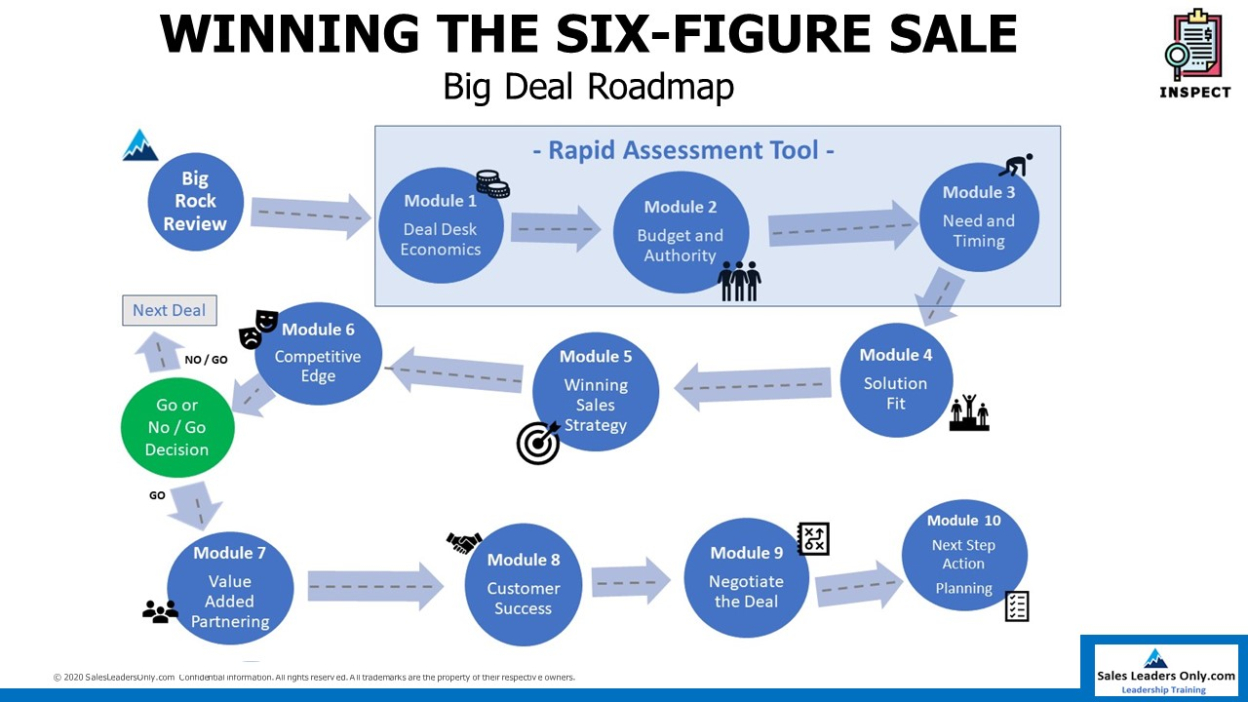

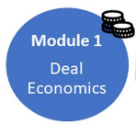1. First Things First: Get your deal approved

Ok, so you’ve found an opportunity that looks BIG and you want to take a run at the deal. Before you spend too much time and get too excited, it’s important that you get your deal approved internally.   
  
Sometimes you have to do your best selling inside your own organization… sound familiar?  
  
Your boss might approve the deal, but since it’s a big one, and you’re likely looking for major concessions from your own company, it’s always a good idea to get your deal approved internally first. At least the broad strokes, so you don’t spend a ton of time working on a deal you won’t get support for.   
  
If you have a deal desk that looks at deals this size, best to bite the bullet early, so you know what your negotiating boundaries are going to look like as you start your campaign.  
  
I know, I know…… if it’s big and you start talking about it, your boss, and potentially her boss will start asking questions!  
  
A cardinal rule of Big Deal selling…. Never loose alone. Get your team involved and get some additional eyes and resources organized and motivated to help you WIN.

**Question 1: What is your Get-Well plan, so you don’t have to sell every future deal to this customer, at this same low price or gross margin?**

If you’re asking for big discounts or low margins, someone above you is going to want to know how you plan to prevent these special concessions from becoming the new norm or baseline moving forward inside the account. Even if they don’t ask, have your Get-Well Plan ready, so you have it should you get internal push back later on.  
  
One-time Upgrade credits, one-time Software coupons or Free training are all good ways to add value that you can position with the customer as special One-Time incentives to close the deal, that you won’t have to offer on the next sale to this customer.  
  
Customers and especially procurement departments, keep track of previous discount levels. Structure your deals so you add your incentives as one off concessions, so you don’t create a base line discount level that will hurt you in the future.

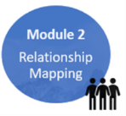2. Relationship Mapping

Major Accounts are often large, complex organizations with many decision makers and recommenders. Titles don’t always tell the whole story, and so one of your primary goals should be to quickly figure out who’s who in the zoo.

Some key contacts will support your solution, some will appose you, some will have no position yet. Job one is to quickly figure out who you need to influence and educate.   
  
You may not yet have access to power just yet, so getting your internal resources (your boss or sales VP) with fancy titles lined up to help you get key introductions will be important.   
  
Channel or Alliance partners may add a lot of value here, if they already have existing relationships in the account.

**Question 2: Have you developed a written Relationship Map and identified all the key players you need to meet and influence?**

Once you start writing down who you need to influence, your list of people to contact and meet will grow (at least it should) quickly. You’ll want to keep track of who you’ve met in person, how they feel about your solution, and whether they are decision makers or recommenders.   
  
Keep in mind that in every complex deal, there are really two sales campaigns you need to run …. at the same time. The Technical campaign and the Economic / Political campaign.   
  
You need a way to keep track of all the players and relationships so you can develop a strategy to close any gaps you identify.  
  
Click here for a copy of the one-page Relationship Map template from [SalesLeadersOnly.com/relationship-map](https://salesleadersonly.com/relationship-map/) you’ll find very helpful in keeping track of all the key players.

3. Follow the Money

There are lots of probing questions here you’ll need to ask, to qualify that the customer has budget and the funds are available to be spent…. Don’t have happy ears on and stop listening when you hear that the budget has been approved.   
  
I can’t tell you how many deals I’ve been engaged with where there was a budget approved months ago (during the budgeting process), but no one thought to ask if the funds had been released.   
  
Large organizations often have a two-step process where funds are budgeted, and then require additional approvals to have the funds released.   
  
Understanding the budget and funding process in the account are table stakes in Major Account selling. Another important question to ask is…..

**Question 3: What is the compelling event that will ensure your deals closes as forecasted…. What happens if you miss the compelling date?**

Since we’re all driven by monthly and quarterly forecasts, it’s critical that you determine if there is some compelling event driving the customer to take action.  
  
Here’s another question where you’ll need to take the happy ears off. If nothing happens if the customer misses the compelling event, it’s NOT a compelling event!  
  
Creating a discount deadline is never very effective if the customer just isn’t ready to buy. Customers are way too smart these days and the market is way to competitive. The quote she received on Friday will be the price she wants to pay on Monday, even if it’s after your quarter end… trust me on this!  
  
Same issue with maintenance renewals. Their maintenance expires on March 1st, so they must place their order before then…. right? The incumbent has complete control over the maintenance pricing and timing and can play all sorts of games.   
  
Maintenance renewal dates are never compelling events…sorry!  
  
There may not be a compelling event that will force the customer to act by a certain date. Just be aware, as this creates risk around your forecasted close date, which could cause you to miss your forecast…. Never a good thing!

4. Solution Fit

Most technology sales reps, and their SEs are very comfortable running the technical campaign. This is where you help the customers understand your value proposition and the features, advantages and benefits of your solution.   
  
You work hard on demos, evals and proof of concepts to ensure the customer understands how your solution fits their requirements.  
  
The best reps focus first on customer needs and the most advanced reps work very hard to understand what Business Outcomes the customer is expecting to achieve from your solution.  
  
Being able to frame the expected Outcomes in business terms, rather then technical terms, gives you a distinct competitive advantage.  
  
Most sellers are focused on the technical capabilities of their solution, instead of tying their solution back to customers needs and expected outcomes. Expected outcomes create urgency for the customer and are a way more powerful selling force then features and benefits.

**Question 4: What business Outcomes is the customer expecting to achieve from your solution?**

Don’t make the mistake of merely presenting your solution as a bunch of PowerPoint facts, figures and features. Connect the dots for your customer by making sure the customer understands (and agrees) that your solution is going to address the key needs and outcomes they’ve identified.

Once the customer has internalized your value proposition, the next critical step is to provide evidence that you can truly do what you say. Case studies, reference visits and calls to other customers in similar industries go a long way to provide proof or evidence you can actually do what you say and solve their problems.  
  
A good way to remember all this is to think about the Acronym NOSE developed by Dr. Tom Sant. Needs, Outcomes, Solutions, Evidence.

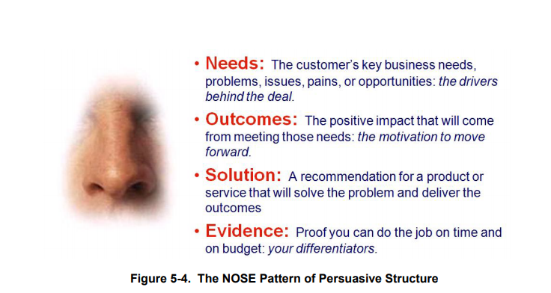

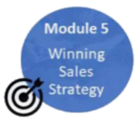5. What’s your Winning Sales Strategy?

Upgrades, Tech Refresh, Big Bang - Rip and Replace, Land and Expand, New Work Loads or Departments, are all sales strategies you can deploy in different customer situations. Each strategy has a pretty well-developed play book you can follow.   
  
A critical question most reps don’t ask is:

**Question 5: Who is the Primary competitor and what is their strategy to beat you!**

Most reps don’t spend nearly enough time thinking about their primary competitor. Do you?  
  
Figuring out how your competition is planning to beat you; helps you stay sharp and run a much better sales campaign. It also enables you to lay traps and land mines for your competition to ensure they blow themselves up.   
  
Always keep one eye clearly focused on how your competitors are planning to take you out! This is where your coach comes in (we’ll get to your coach in just a moment).

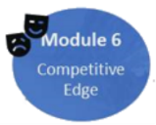6. What’s your Edge?

In every complex sales campaign, there will be ups and downs with small victories and setbacks along the way. The trick is to see if you can develop a competitive Edge in your campaign.   
  
In Las Vegas, the house has an edge of 1.5 – 4 percent, and that small advantage is enough to make casino owners rich and famous (and to provide free drinks while you’re gambling).   
  
You can certainly win a big deal without an Edge, but it sure makes things easier if you have one.

**Question 6: Do you have access to Power, and have you met the key decision makers in person?**

Meeting key Decision Makers in person and taking off the happy ears to learn exactly what Outcomes they’re expecting, is a huge advantage or edge in your campaign. Ruthlessly qualifying where you stand with them is also hugely important.   
  
You would think that the key contacts inside your prospect talk to each other all the time and are completely aligned around their needs and potential solutions, but that’s simply not the case.   
  
Often technical buyers and economic / political decision makes don’t speak the same language at all, and your job is to bridge the gap and gain perspective.   
  
How often has your technical recommender told you they are making the decision and not to go over their heads…. A thousand times?   
  
If you’re not talking to key decision makers (the people who can say YES to your deal), it’s highly likely the incumbent competitor, who already has a relationship in the C suite is.   
  
You may not have access to power yet, but you need it!  
  
Get your boss, or someone in your company with a fancy title to help, or leverage a Channel or Alliance partner who does, and have them sponsor you in to meet the key decision makers…in person!

**Question 7: Who is your Coach and are they sharing key information about how your sales campaign is being perceived inside the account?**

I’ve found it critically important to develop a coach inside the account, as you work through your sales campaign.   
  
You need visibility inside the customer to understand how your campaign is being perceived. Does the prospect like your pricing strategy and approach? What part of your value proposition has grabbed their attention? What is the competitor up to and are they gaining traction?   
  
A coach tells you if you’re hitting the target and helps you maneuver inside the account.   
  
You can win without access to power, but it’s very hard to mount a successful, large sales campaign if you have no visibility into what’s working and what’s not.   
  
Developing a coach is a Huge advantage or Edge and one your competitor will be working hard to develop. Make sure you are too!

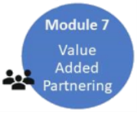

7. Value Added Partnering

In todays’ IT world (and many other industries as well), there are very few vendors left who have a Direct First strategy. To gain market share and leverage, most vendors are looking to maximize their routes to market and team with partners to cover more territory and gain access to new customers?

Some of the biggest objections I hear from vendor reps for not using Channel or Alliance partners is they add no value. They don’t know the products or solutions very well and can’t take a campaign from start to finish?   
  
“If I have to do all the work myself anyways, why do I need them? They’re a channel tax I end up paying for, with little return”.  
  
What I always ask when a rep raises these issues is….. If you feel they bring no value, why did you register that partner in the first place? What value did you see when you accepted their deal registration?   
  
The challenge is that Partner Value comes in many flavors.   
  
Sometimes the partner introduces you into the deal you didn’t know about. If you don’t register the partner, there’s no deal.  
  
Sometimes the partner has been selling into the account for a long time and has existing relationships in procurement, that can shorten the time and complexity to get your PO once you’ve got the green light.   
  
Sometimes the partner has a selling vehicle and can get the PO without a lot of extra steps (3 quotes, public tender…) in the procurement process.   
  
And sometimes the partner has Access to Power because they have existing senior relationships.  
  
It’s very rare that a partner will know more about your product’s technical capabilities then you do. Vendors only sell their own kit, while partners need to learn and sell multiply vendors products and solutions.  
  
The most important partnering question I always ask is:

**Question 8: Do you have a written Roles and Responsibilities agreement with your partner?**

Before you EVER accept a deal registration from a partner, the vendor and channel reps should discuss exchanged value. What is each partner bringing to the table to win the deal?   
  
Even more important then the discussion, is a written follow up email which quickly summarizes what each partner has committed to.  
  
Most reps don’t bother with the last step (a follow up email) and end up with poor expectations around what each person is going to do, and what role they will each play.   
  
So, take a moment and send an email after each deal registration, to get your partnership off on the right foot.  
  
If reps can’t agree on what value each brings to the deal, they are better off agreeing NOT to partner, then accepting a deal registration and not engaging each other.

The other question I ask a lot is:

**Have the partner and vendors reps shown up TOGETHER in front of the customer**?   
  
If the answer is no, then a big red flag goes up and I start to ask more questions about what value is being exchanged between the sales teams.   
  
If you aren’t getting any leverage from your partner in the deal, you’re missing a huge opportunity to leverage each other’s sales resources to cover more ground inside the account.

 8. Customer Success

**Question 9: What is your strategy to ensure customer success?**

This seems like a straightforward question, but in the heat of the battle to win the sale, many sales teams lose focus on two other critical components of a successful customer experience**.**Sell, Install and Support.   
  
You can sell a customer anything once, but if the implementation doesn’t go well and their first customer support experience is poor, you take one step forward and two steps backwards.  
  
Annuity business is the holy grail in Complex account selling. Do everything possible to win the footprint, and if the customer has a great first experience, you’ll usually be able to go wide and deep and sell that same customer way more stuff!  
  
The follow-on sales, once you’ve developed a track record of success inside the customer, usually take less effort and less discounting to win. They’re now a happy annuity customer.  
  
Thinking about what happens after the sale and baking that into your sales campaign pays huge dividends.   
  
Bundling in training credits, providing some implementation consulting assistance or knowledge transfer are just some of the things you can include as part of the initial selling process that makes implementation and support that much easier to execute.  
  
Customers love when you look over the horizon and demonstrate you’re thinking about their Success, not just your commission cheque.



9. Next Step Action Planning

As you progress through your sales campaign, it’s critical you maintain and communicate a list of open action items that require attention from your team.  
  
The best reps always have a gut feel for what’s going well, and what isn’t.  
  
Question 10 forces you to confront what you already know (and hope the customer won’t discover) about the flaws, perhaps fatal flaws in your campaign.

**Question 10:** **If the prospect was to notify you today that you lost the deal, what fatal flaws in your campaign do you think they discovered that led to the loss…**

**What steps will you take now to address the flaws before you get the bad news phone call?**

By asking yourself this final Look Back question, you shine a bright light on your weaknesses before it’s too late. Remember, question 10 is something you ask yourself. What are you missing, what gaps do you have that need to be covered off?

You then need to go figure out how to turn these flaws into strengths or at least neutralize them, so they don’t kill your deal before it’s too late.

Summary

There they are… the Top 10 Questions you should be asking… but probably weren’t…... until now!  
  
These 10 questions are part of the [35 Question Big Rock Review](https://salesgrindersonly.com/course-1/) process and roadmap I teach in my sales course WINNING THE SIX-FIGURE SALE.   
  
I developed the course after reviewing over 200 complex sales campaigns with my sales teams over the past 5 years at both NetApp Canada and Veeam Software.  
  
I found that by following the Big Deal Road Map, completing the Relationship Map and working the Big Rock review process, sales teams dramatically improved their Big Deal win rates.  
  
Following an intentional and deliberate sales process helps sales team members work together more effectively to run MUCH better winning sales campaigns.  
  
Technology, always changing, always evolving…. It’s the life we choose.  
  
Great selling.

[Jeff@SalesLeadersOnly.com](mailto:Jeff@SalesLeadersOnly.com)

PS. If you’re interested in learning more about the WINNING THE SIX-FIGURE SALE program…... read on!

Next Steps?

This Special Report has been developed as part of the WINNING THE SIX-FIGURE SALE video sales course and my upcoming book…. available soon.   
  
The course will help Large Account Sales professionals (Reps and Leaders) ruthlessly qualify their Big Deals and only spend time and resources on deals they can win, while learning how to ask the right questions, of the right buyers, so they never miss an important step in the Sales Process.   
  
The entire REVIEW process is fast, repeatable and takes less then one hour to complete .... regardless of how complex the deal is.

Leaders win their big deals that matter most. This course will help you dramatically improve your BIG DEAL win rate by following a structured question-based approach.

The course is available today via Live (zoom) video conference.

**The WINNING THE SIX-FIGURE SALE course will help you:**

* 1. Get more **Focus** on your **Big Rocks**, by Ruthlessly qualifying and never spending time or resources on deals you can’t win.
  2. Dramatically **improve** your **BIG DEAL** win rate by **never missing** an important step or stakeholder in your sales campaign.
  3. Develop a **Consistent** and **Repeatable** Review and Inspection process that is **quick,** and very **complete**… less then 1 hour.

**What you get with the course:**

* Live On-line training program describing each step of the sales process with 35 high impact questions to gain unique insight into your deal.
* Downloadable Big Rock Review template you complete to document and share the details of your deal.
* Downloadable Relationship Map to easily track key decision makers and recommenders you’ll need to meet and influence.
* Downloadable Big Rock Review real life examples with a Best Practices guide to help you understand and quickly implement the Big Rock Review process.
* Downloadable Next Step Action planner to help hold you and your team members accountable.
* Downloadable Big Deal Scorecard to track your new Big Deal Win Rate.
* Access to a Q&A section on my website to get answers to your ongoing implementation and support questions.

This Course **IS NOT:**

* + About Account Planning.
  + Marketing.
  + Or Prospecting and filling the funnel.

This Course **IS:**

* + About inspecting Complex or Strategic “Must Win” Single Sales Opportunities.
  + Ruthlessly Qualifying so you only spend time and resources on Big Deals you can win.
  + Improving your Sales Campaign and Covering all your bases so you never missing an important step or stakeholder in the sales process.
  + Dramatically improving your BIG DEAL win rate.

WINNING THE SIX-FIGURE SALE teaches a Structured approach to Inspecting, Assessing and Coaching Must Win Sales Campaigns…. The deals that move the forecast needle.

**Visit** [**https://salesleadersonly.com/course-1/**](https://salesleadersonly.com/course-1/) **for more details.**

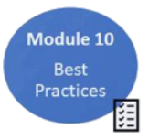Additional Resources

[**SalesLeadersOnly.com**](https://salesleadersonly.com/)web site.

[**Relationship Map**](https://salesleadersonly.com/relationship-map/)**:** you’ll find this template very helpful keeping track of relationships inside the account.

**Big Rock review template:** The template walks you through each step of the review process and asks the most critical questions you need to consider in each step of your campaign. Available with the course.

**Next Step Action Plan** – Rep documents Action Items from the review, to be completed by team. Available with the course.

**Quarterly Score Card in Excel** – Leader Completes. Available with the course.

**Best Practise Implementation Guide** – for both the sales team and leader. Available with the course.

**Questions:** Contact [jeff@SalesLeadersOnly.com](mailto:jeff@SalesLeadersOnly.com)

](https://salesleadersonly.com/new-book-notice/)Get notified when my new book is published …. [February 2021](https://salesleadersonly.com/new-book-notice/)